Nepal College of Information Technology
Unit Test
Fall 2011
Program : BE ELX/CE Time : 2 hrs
Semester : Fall (V) FM : 70
Subject : Integrated Digital Electronics PM : 35

- Candidates are requested to give their answer as far as practicable in their own words.
- The figure in the margin indicates the full marks
- Attempt ALL question

1. | a. | Explain in detail, how the circuit shown below works as a logic inverter. Assuming β=70, V_{BE (on)} = 0.65V, V_{BE (sat)} = 0.75V, V_{C E (sat)} = 0.2 V, explain in detail and plot its VTC.  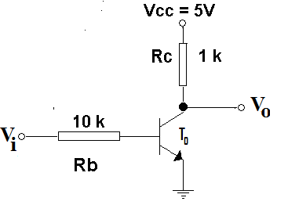 | 2+6
 | b. | Draw and explain a 3-bit IIL decoder. | 7
2. | a. | Stating all necessary assumptions you make, answer the following questions referring the following circuit.  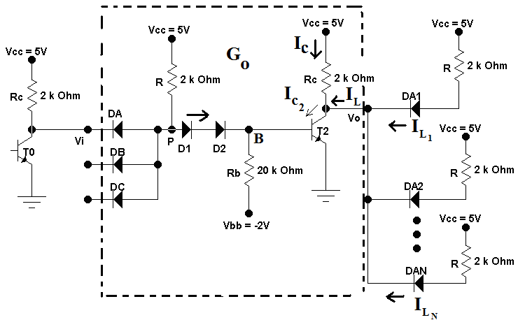 | 10
 |  | - Explain how the circuit enclosed in dotted line (G₀) works as a 3-input NAND gate.  - Calculate the potential at points P and B when the output transistor (T₀) of the gate G₀ is in saturation.  - Calculate the potential at points P and B when the output transistor (T₀) of the gate G₀ is in active region.  - Calculate the current flowing through the base resistor R_{b} when the input(V_{i}) is low and when the input(V_{i}) is high.(assume no inputs are applied to DB and DC diodes)  - What is the role of base resistor R_{b} and the negative supply V_{bb} in the circuit above? | 2  2  2  2  2
 | b. | Derive an expression for the fan-out (N) for the DTL gate G₀ shown above. | 5
3. | a. | Define noise margin. Calculate ∆0 and ∆1 noise margins for the ordinary RTL NOR gate at temperatures 125°C and -55°C.Assume, temperature sensitivity of base emitter junction is - 2 mV/°C. | 10
 | b. | What are the reasons for the delay in propagation in gates? Explain why the turn-on delay of the output transistor in DTL is smaller than the turn-off delay. | 5
4. | a. | Draw an Exclusive-OR circuit using RTL and explain its operation. | 7
 | b | Draw the input-output characteristics of RTL NOR gate for a fan-out of N=5 at 25 °C. | 8
5. | b. | Write short notes on (Any Two)  - Current Hogging in DCTL  - RTL NOR gate  - Significance of active pull-up in gates. | 2×5

